James Korenman

Class Activity 11/18/22

Buffalo Screenshots:

Decolonizing Development Education Screenshots:

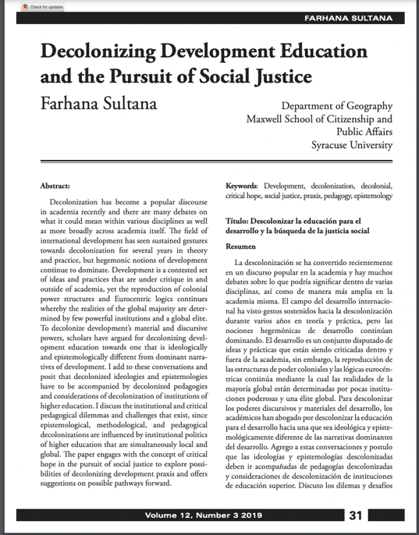

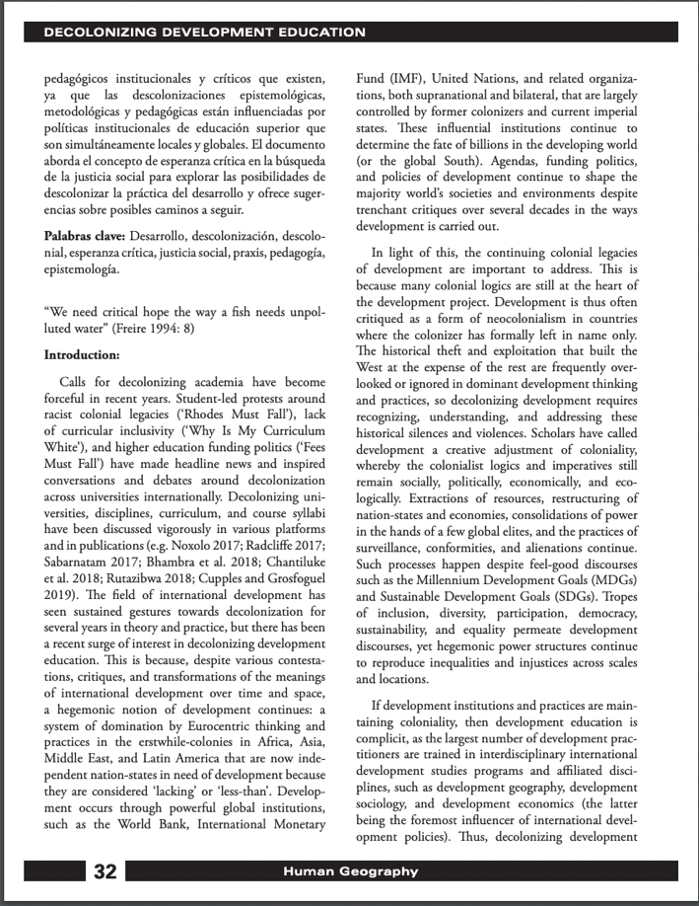

Research as Resistance Screenshots:

3. The copyright page is where all the information about the book or article is, like it authors, editors, and publishers. It is important as it gives credit to those who have created the document or book, and can be a valuable resource when citing certain sources in another paper.